**SORTING REQUIREMENTS**

You can sort the requirements by just clicking on the requirement field

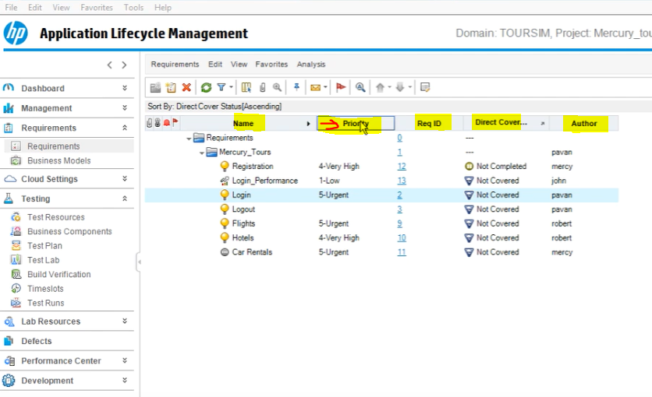

It can be ascending order 1,2,3,4,5, if you click again it will be descending order 5,4,3,2,1

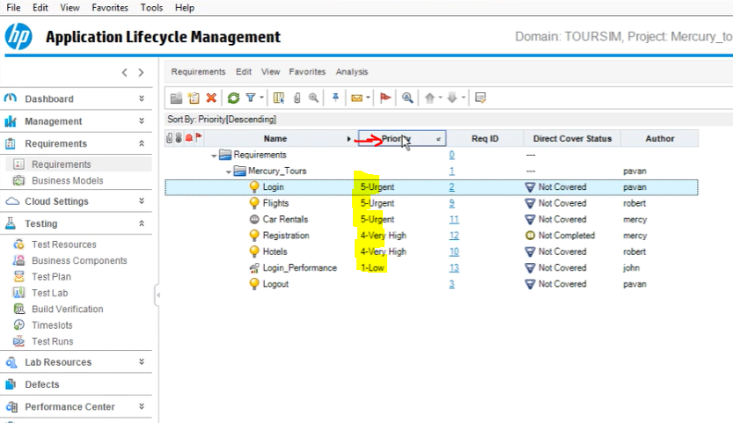

You can do the same sorting for author or anther filed by clicking on it.

Also you can remove sorting by removing the filter/sort

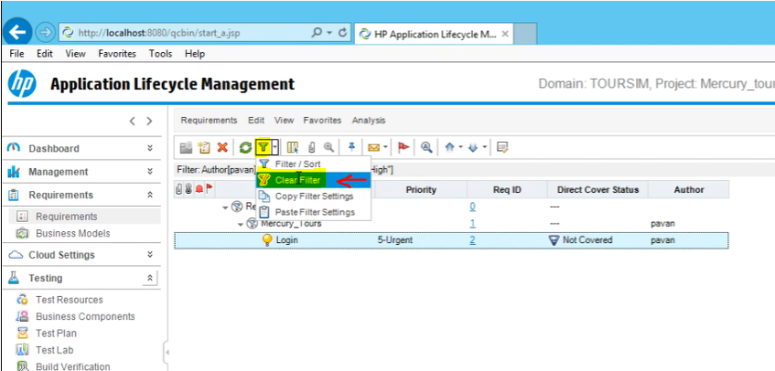

If you want to sort for more than one criteria, you need to click on “filter/sort” then,

Select view Order then select the Criteria.

The one on the top has the priority so in this example “priority has the first priority”

However, you can change and put the “author” top by using the UP and DOWN arrow buttons

Also, Small Arrows for ascending or Descending order

